Task #1  
  
Prompt:  
  
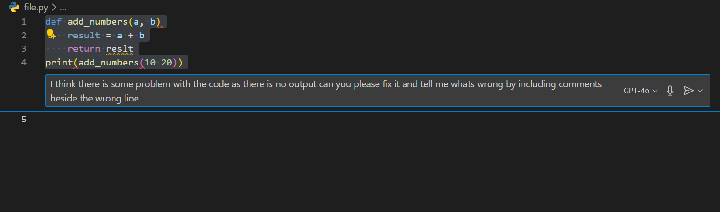  
  
Code:  
  
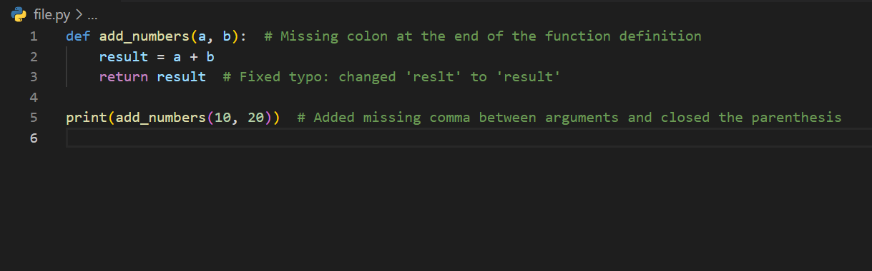  
  
Output:  
  
  
  
  
  
  
  
  
  
  
  
Task #2  
  
Prompt:  
  
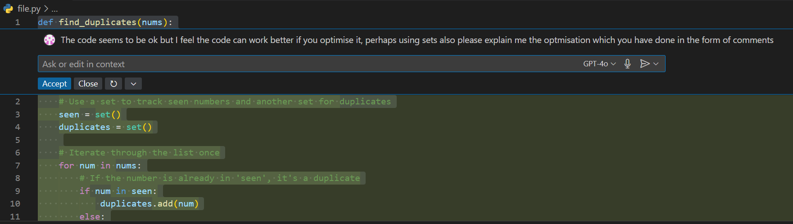  
  
Code:  
  
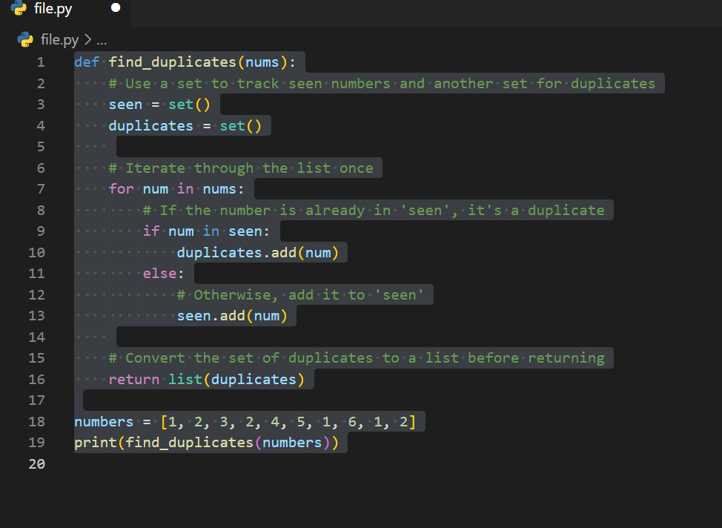

Output:

  
  
  
Task #3  
  
Prompt:  
  
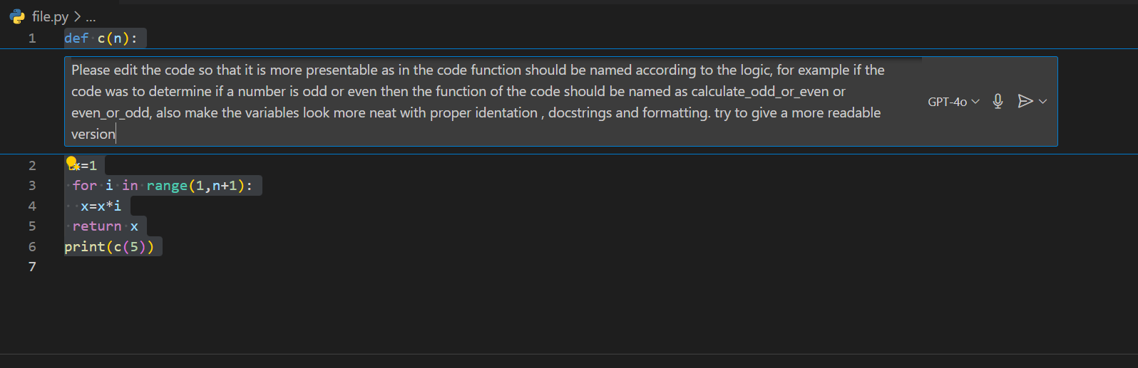

Output:  
  
  
  
The code is optimized along with proper identation to even find factorials of big numbers as well.

Code:  
  
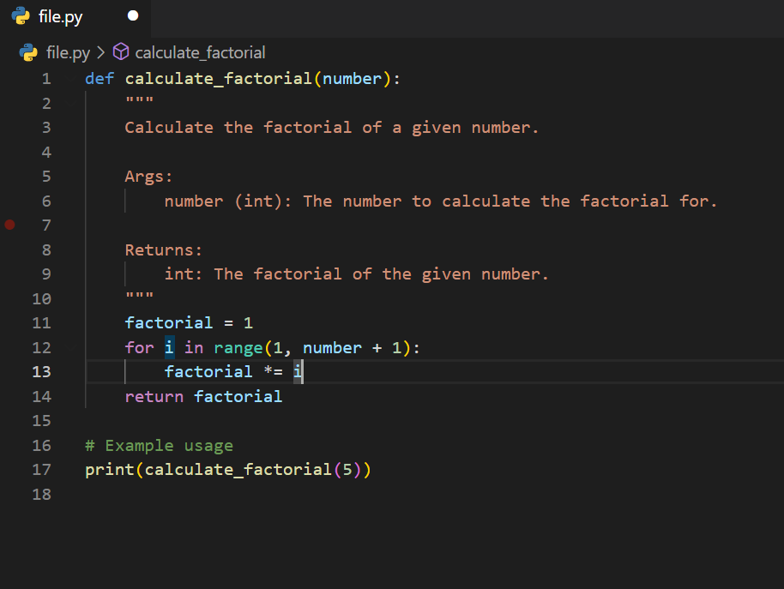

Task #4  
  
Prompt:  
  
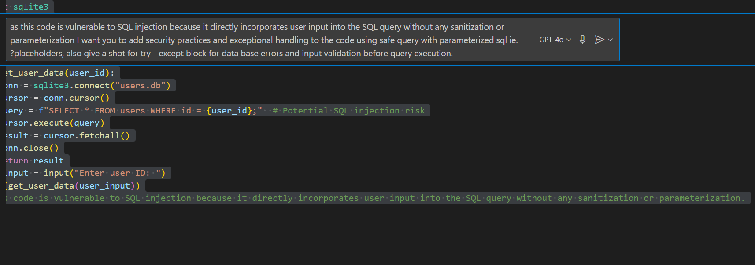

Output:  
  
  


Code:  
  
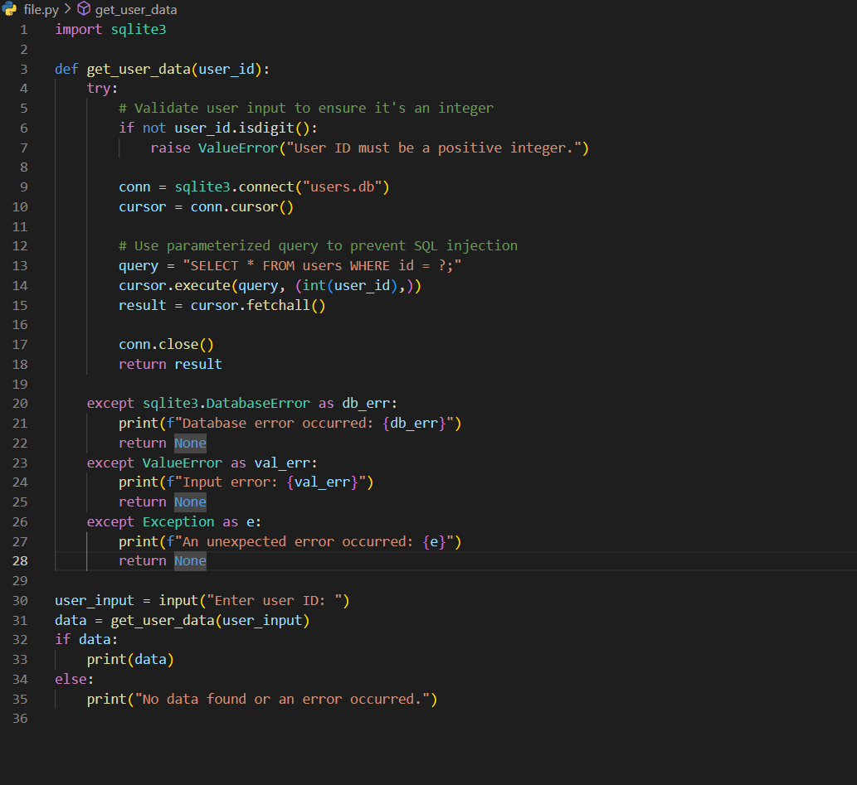  
  
  
Task #5  
  
prompt:  
  
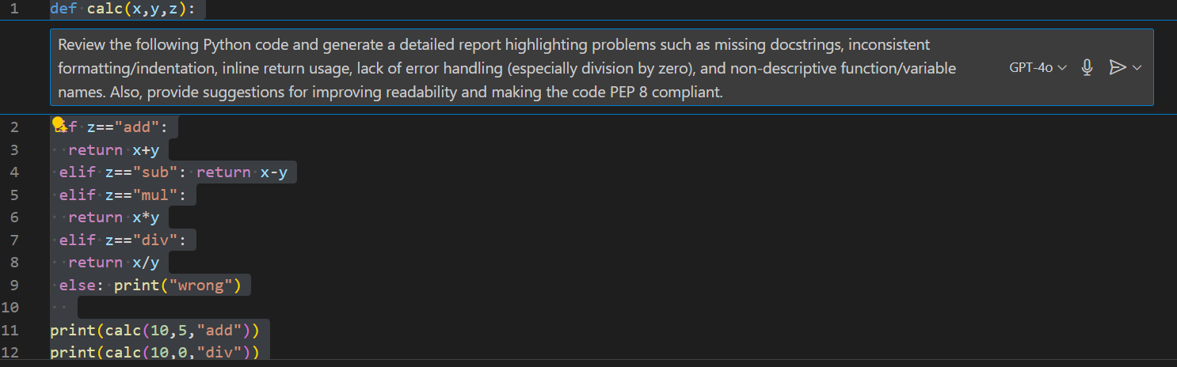  
  
  
output:  
  


code:  
  
